**A Minor Project-I Proposal On**

# Question Bank

Submitted in partial fulfillment of the requirements for the degree of Bachelor of Engineering in Software Engineering at Pokhara University

## By

**SUMAN ADHIKARI ASHISH PAUDEL SHUVAM GAUTAM**



## Department Of Research and Development GANDAKI COLLEGE OF ENGINEERINGANDSCIENCE

Lamachaur, Kaski, Nepal

**A Minor Project-I Proposal On**

# Question Bank

Submitted in partial fulfillment of the requirements for the degree of Bachelor of Engineering in Software Engineering at Pokhara University

## By

**SUMAN ADHIKARI** **ASHISH PAUDEL** **SHUVAM GAUTAM**

## Supervisor

**Er. Krishna Khadka**



## Department Of Research and Development GANDAKI COLLEGE OF ENGINEERING AND SCIENCE

Lamachaur, Kaski, Nepal

# BONAFIDE CERTIFICATE

This is to certify that this project titled **“Question Bank”** partial fulfilment of the requirements for the degree of BACHELOR OF ENGINEERING IN SOFTWARE ENGINEERING is a bonafide work of **Suman Adhikari, Ashish Paudel** and **Shuvam Gautam** under the supervision of **Er. Rajendra Bahadur Thapa**. It is further certified that this work doesn’t form part of any other project work based on which a degree or award was conferred on any earlier occasion on this by any other candidate.

**Date of Evaluation**: **November 13, 2022**

……………………………...…

Er. Rajesh Kamar

External Examiner

Assistant Professor

School of Engineering, Pokhara University

……………………………...… ………. ……………………….

Er. Krishna Khadka Er. Rajendra Bahadur Thapa

(Supervisor) Project Head

Research Management Cell

i

**ACKNOWLEDGEMENT**

This project work has been accomplished with the guidance of our supervisor **Er. Krishna Khadka** who has given his full effort in guiding the team in achieving the goal as well as his encouragement to maintain our progress in track. So, we would like to express our sincere gratitude and appreciations to our project head.

We would also like to express our special thanks of gratitude to our vice-principal who gave us the golden opportunity to do this wonderful project on the topic **“Question Bank”**, which helped us in doing a lot of Research and we came to know about many things and many appreciations the crucial role of the GCES staff at the department who provided constructive guidelines, and information during our project work.

Lastly, we are over helmed in all humbleness and gratefulness to acknowledge our depth to all those who have helped us to put these ideas, well above the level of simplicity and into something concrete.

ii

# ABSTRACT

As we all know that finding old questions is very difficult at the last moment of examination. As well as many students are not familiar with the question pattern that can be asked in examination. Searching questions in various platforms consume more time which directly affects on the preparation of exam.

The main objective of our project is to build a system that provides PU based questions. We provide questions related to different subjects and those questions can be viewed in single platform or in a single page which can be viewed without downloading.

Question Bank is web application where students can find all questions in a single platform

.This helps students in saving time and focuses more in question solving rather than question searching.

iii

**TABLE OF CONTENTS**

BONAFIDE CERTIFICATE i

ACKNOWLEDGEMENT ii

ABSTRACT iii

LIST OF FIGURES ……………………………………………...………iv

LIST OF ABBREVATIONS …………………………………………..…v

CHAPTER-1

INTRODUCTION 1

* 1. 1.1 BACKGROUND 1
  2. 1.2 PROBLEMSTATEMENT ……1
  3. 1.3 OBJECTIVE 1
  4. 1.4 IMPLICATION 1

CHAPTER-2

LITERATURE REVIEW 2

2.1 PU ASSIST 2

2.2 CSIT HUB 2

2.3 IOE NOTES 2

CHAPTER-3

TOOLS AND METHODOLOGY ……………………………………3

* 1. 3.1 METHODOLOGY 3
  2. 3.2 REQUIREDTOOLS 4

3.3 UCD Diagram ………………………………………..….4

3.3.1 UCD1 5

3.3.2UCD2…………………………………………….5

SSD Login………………………………………….……….6

SSD Data Entry… ………………………………………….7

SSD Question…………………………………………….….8

ERD ……………………………………………………….…9

CHAPTER-4

RESULT AND DISCUSSION………………………………………..….10

CHAPTER-5

CONCLUSION AND RECOMMENDATION……………………….……11

APPENDIX I ………………………………………………………...…...12

BIBLIOGRAPHY ……………………………………………….………..13

# List of Figures

Figure 3.1: Waterfall Model Figure 3.2: Use Case Diagram Figure 3.3: SSD for Login Figure 3.4: SSD for Data Entry Figure 3.5: SSD for Question Figure 3.6: ERD

Figure 3.7: Gantt chart for Question Bank

iv

# List of Abbreviation

ERD: Entity Relation Diagram CD: Class Diagram

PHP: Hypertext Preprocessor SQL: Structured Query Language SSD: System Sequence Diagram UCD: Use Case Diagram

UML: Unified Modeling Language

v

# Chapter 1

## INTRODUCTION

### 1.1 BACKGROUND

While examination students have to cover as much topic as possible. Fear of managing time directly impact on students confidence, capacity to learn, difficulty in covering the entire syllabus and focusing on individual chapters. But this problem can be eliminated and minimized with the help of Question Bank. It is a fast, easier and time saving platform which students can use to enhance their learning process.

### 1.2 PROBLEM STATEMENT

In the context of Students it is very difficult to access the questions and cover the whole syllabus during short exam period. Most of the students are not familiar with the question pattern that can be asked in examination. Searching questions consumes more time which directly affects on the preparation of the exam.

### 1.3 OBJECTIVES

The main objectives of our project are:

* + - To build a system that provides PU based questions related to different subjects in single platform .

### 1.4 IMPLICATION

This system is especially for the students preparing for the exam.

# Chapter 2

## LITERATURE REVIEW

We found many apps and web applications in the market that already have been developed. Besides these apps we are developing question management system that is suitable for students .In these section we mention briefly a few of these application

### 2.1 PU Assist

It is an mobile application which is developed by Bazar Hub Pvt.Ltd in 2018. Which has limited features .Drawback of the application is that we cannot access all the semester’s question in one page.

(Pu assist, n.d.)

### 2.2 CSIT Hub

csithub.com is an web application which is developed by the student of csit. This has limited features. Drawbacks of the application are that we have to go through various tabs to download the questions.

(csithub, n.d.)

### 2.3 IOE NOTES

IOE NOTES is an web application which share Notes, Syllabus, Questions, Entrance Exam, Drawing Solutions, Projects along with new and updated syllabus with course contents and marking scheme of Institute of Engineering (IOE) for Bachelor (BE) and Masters (ME) level.. This has limited features. Drawbacks of the application are that we have to go through various tabs to download the questions.

(IOENOTES, n.d.)

# 

# Chapter 3

## TOOLS AND METHODOLOGY

### 3.1 METHODOLOGY

In our project we will be using waterfall model. The Waterfall Model was the first Process Model to be introduced. It is also referred to as a linear-sequential life cycle model. It is very simple to understand and use. In a waterfall model, each phase must be completed before the next phase can begin and there is no overlapping in the phases. The waterfall model is the earliest SDLC (Software Development Lifecycle) approach that was used for software development. In “The waterfall” approach, the whole process of software development is divided into separated phases. In this Waterfall model, typically, the outcome of one phase acts as the input for the next phase sequentially.

Waterfall model.(n.d).

Advantages of waterfall model:

* + - Easy to understand and implement
    - Identifies deliverables and milestone
    - Work well in mature deliverables
    - Good for smaller projects
    - In this model phases are prepared and completed one at a time.

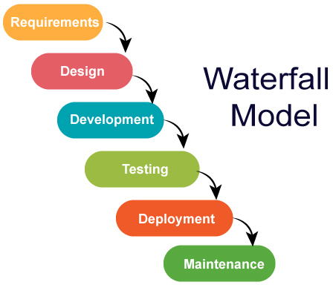

**Fig 3.1: Waterfall Model**

### 

### 3.2 REQUIRED TOOLS

The tools required are:

* + - PHP
    - Xampp
    - GitHub: For Version Control
    - Databases: MySQL
    - Visual Studio Code/ Sublime Text
    - Web browser: Google Chrome, Brave
    - Lucid Chart: For UML Design
    - Gimp: For Wire Frame Design

### 3.3 USECASE DIAGRAM

There is a user and admin in our system and his/her cases are shown below:

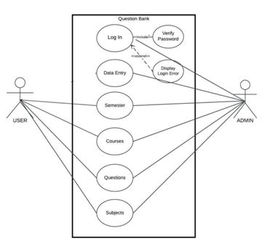

### Figure 3.2 Use Case Diagram for Question Bank

**Use Case UC1:** Data Entry

**Primary Actor:** Admin

**Pre Condition :** Admin must login.

**Post Condition :** System shows the action for show, add, edit and delete.

## Basic Flow:

* System show the form for data entry.
* Admin choose the actions.
* System shows the UI according to the actions

## Alternative Flow:

If actions are failed then system shows the error message.

**Use Case UC2 :** Question

**Primary Actor :** Admin

**Pre Condition :** Admin must login.

**Post Condition :** System shows list of questions.

## Basic Flow:

* System shows the listed questions from database.
* Admin add new question.
* Admin choose the actions.
* System shows the UI according to the actions

## Alternative Flow:

* If actions are failed then system shows the error message.

# SYSTEM SEQUENCE DIAGRAM

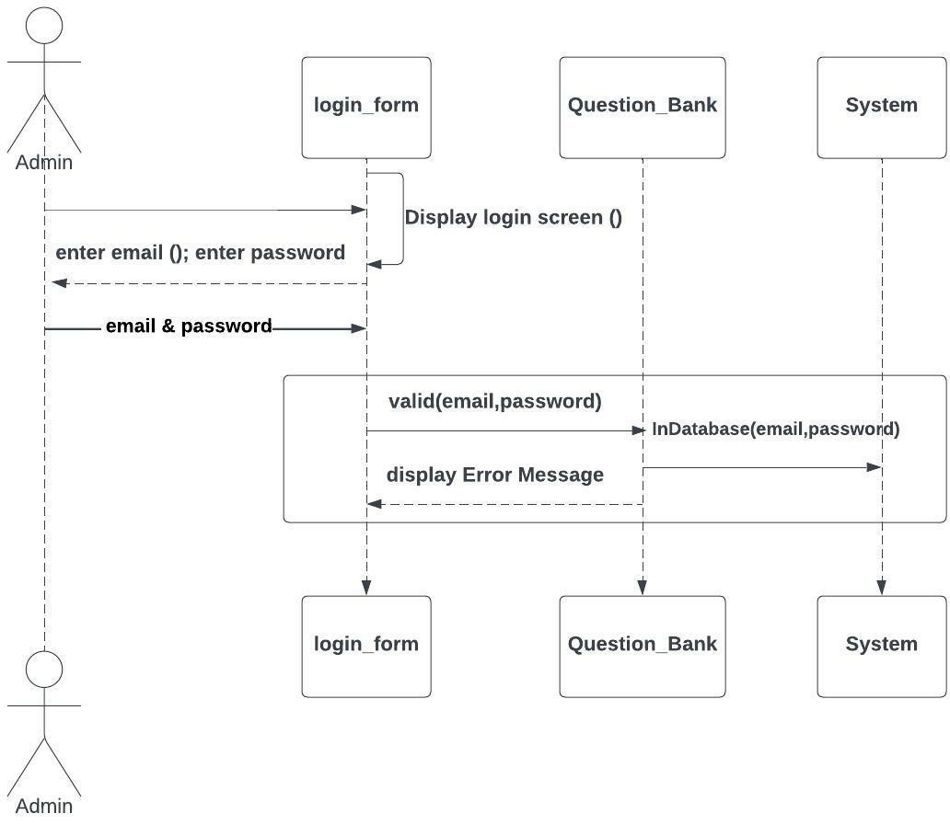

**Figure 3.3 : SSD for Login.**

# SYSTEM SEQUENCE DIAGRAM

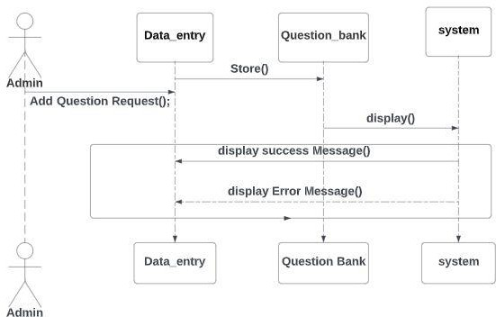

**Figure 3.4 : SSD for data entry.**

# SYSTEM SEQUENCE DIAGRAM

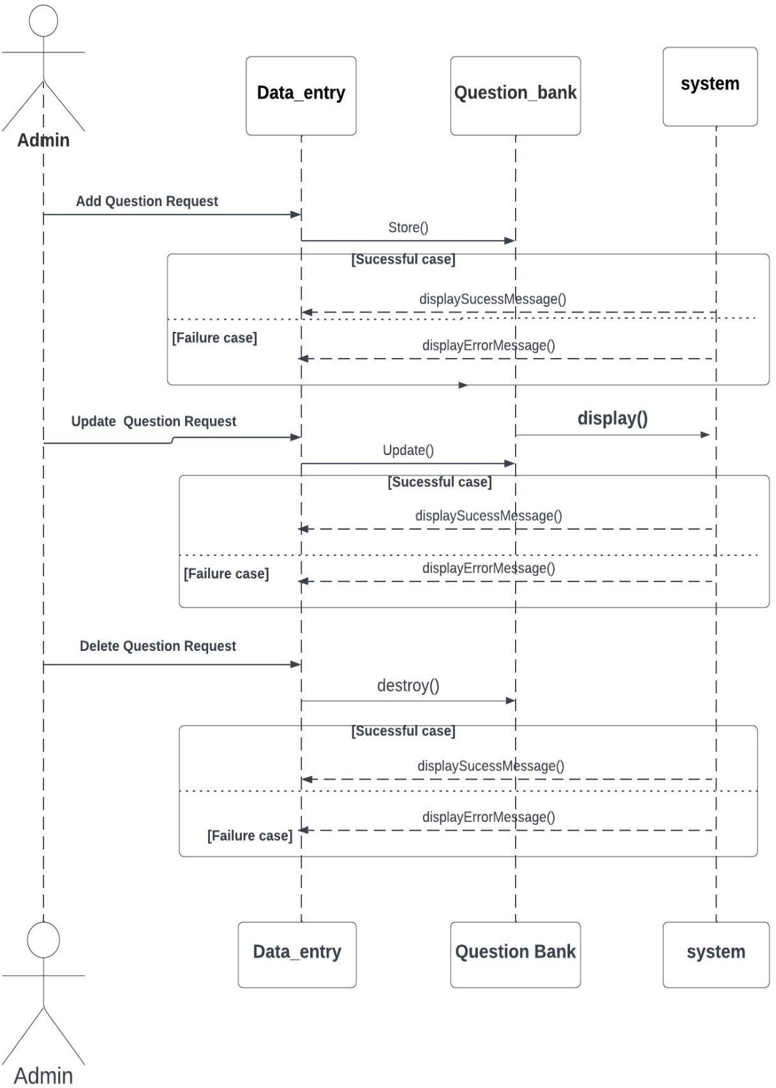

**Figure 3.5 : SSD for Question.**

# ERD : ENTITY RELATIONSHIP DIAGRAM

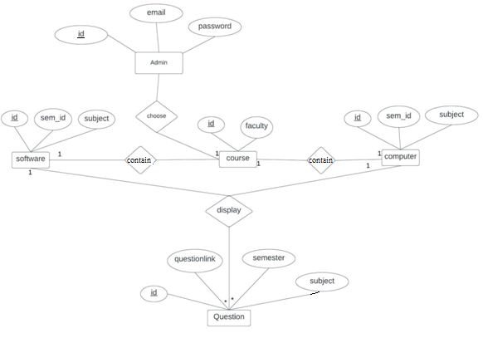

**Figure 3.6 ERD for Question Bank**

# Chapter-4

**RESULT AND DISCUSSION**

**4.1 RESULT**

The software project for college was a success. We are able to learn new programming techniques and apply them to a real-world problem. We are also able to work together as a team to solve problems. We learn how to work together as a team and communicate effectively. The project was a great way for us to learn about the different software programs and how to use them. This software project also helps us to learn new skills

**CHAPTER-5**

**CONCLUSION AND RECOMMENDATION**

**5.1 CONCLUSION**

The software project was completed successfully and on time. The team worked together well and communicated effectively. The project supervisor was able to keep the project on track. The final output was tested and found to be free of defects. The project meets all the objectives that is helpful for the students to focus on question solving rather than question searching. In this project we develop a web application where students can find past questions of any faculties that can be asked in their examination. This web application can be used by students and teachers.

**5.2 RECOMMENDATION**

Based on the project we have to follow up the modern way for question searching rather than using traditional way using those paper trials. It will be the good use for those students who are planning to study those questions that are asked in the examination only.

# 

# APENDIX I

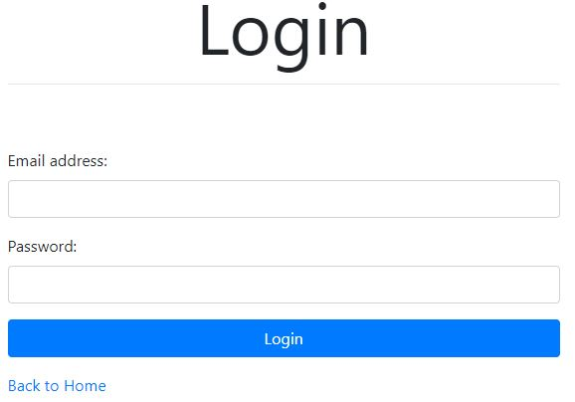

**Login Interface**

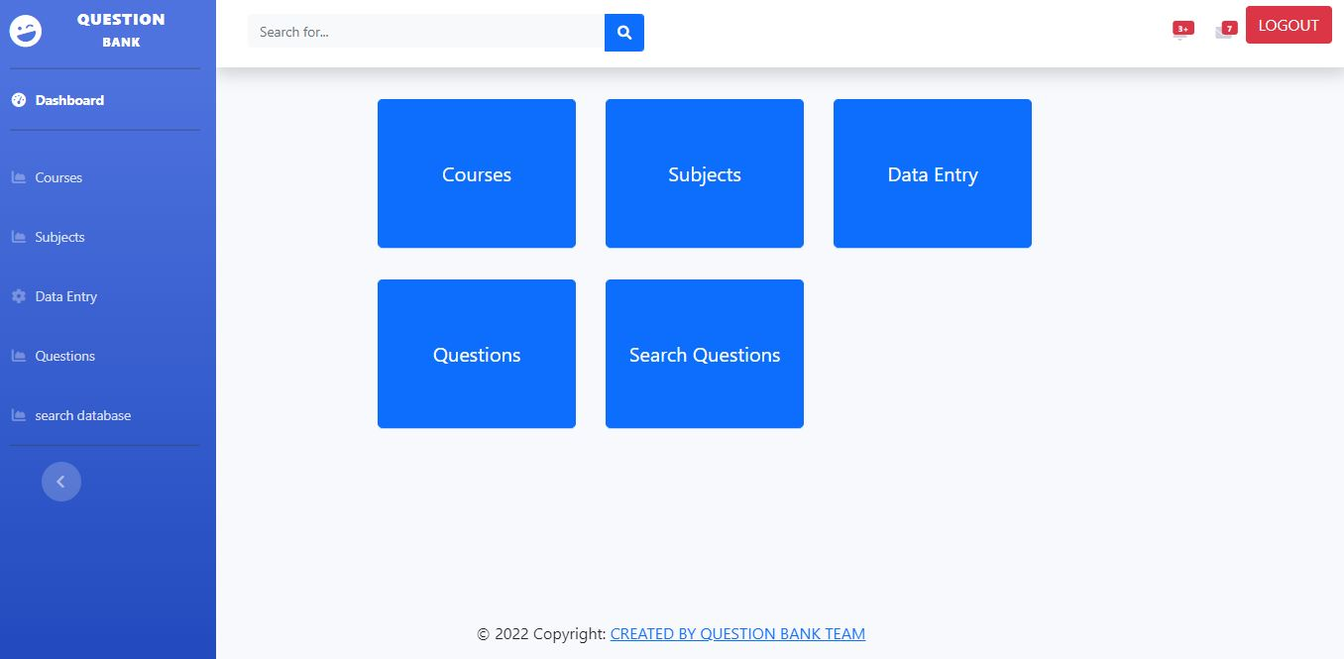

**Admin Interface**

# Bibliography

csithub. (n.d.). Retrieved from https:/[/www](http://www.csithub.com/bsccsit-old-questions).[csithub.com/bsccsit-old-questions](http://www.csithub.com/bsccsit-old-questions) dotnepal. (n.d.). Retrieved from https://dotnepal.com/category/education/study-notes/ Ioenotes. (n.d.). Retrieved from https:/[/www](http://www.ioenotes.edu.np/questions).[ioenotes.edu.np/questions](http://www.ioenotes.edu.np/questions)

Pu assist. (n.d.). Retrieved from https://play.google.com/store/apps/details?id=com.thesaugat.puassist&hl=en&gl=US. Waterfall model.(n.d).Retrived fromhttps:/[/www](http://www.tutorialspont.com/sdlc/sdlc_waterfal_model).[tutorialspont.com/sdlc/sdlc_waterfal_model](http://www.tutorialspont.com/sdlc/sdlc_waterfal_model)